**IOT Based Smart Parking System**

A Project report submitted in partial fulfillment of the requirements for the degree of B.E in

Computer Science Engineering

By

**M.KEERTHANA (513221104014)**

Under the supervision of the Professor & HOD department of

Computer Science Engineering

**Phase 5: Project Documentation & Submission**

In this section you will document the complete project and prepare it for submission

INTRODUCTION:

Sound, a normal feature of our life, is the means of communication and entertainment in most animals, including human beings. It is also a very effective alarm system. A low sound is pleasant whereas a loud sound is unpleasant and is commonly referred to as ‘noise’. Noise can be defined as an unpleasant and unwanted sound that is loud and disruptive to hearing. There are 4 different types of noise: continuous, intermittent, impulsive and low frequency. Continuous noise refers to noise that is produced continuously by machinery that does not stop working while intermittent noise refers to the quick rise or drop in the noise volume. Additionally, impulsive noise is characterised by its sudden and fast nature. Low frequency noise refers to the background noise that we hear in our surroundings. These 4 types of noise contribute to the noise pollution that we experience daily, especially in our highly urbanised world today.

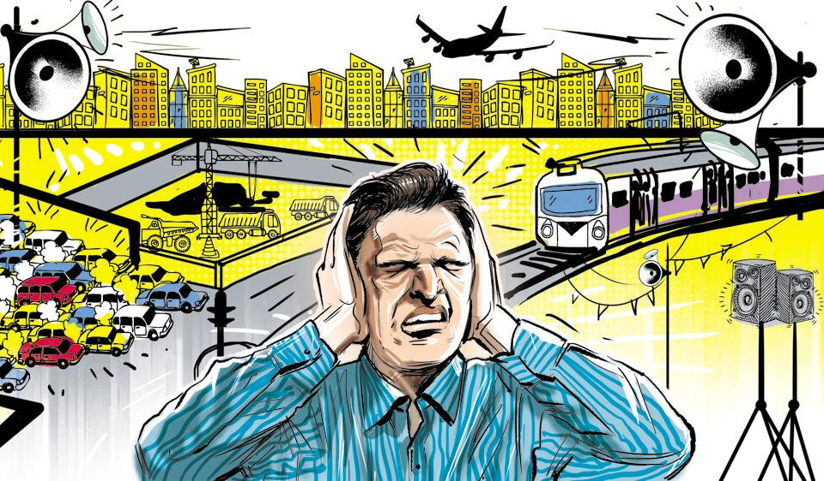

* Problem statement
* Design thinking approach

**PROBLEM STATEMENT:**

Noise pollution impacts millions of people on a daily basis. The most common health problem it causes is Noise Induced Hearing Loss (NIHL). Exposure to loud noise can also cause high blood pressure, heart disease, sleep disturbances, and stress.

Noise pollution is caused by extremely loud sounds and is very discomforting and painful for the ears. It may also cause health problems like hypertension, lack of sleep, anxiety And many more

Inform the public, especially persons affected by environmental noise, as well as policy and decision makers, of the dangers of noise pollution.

Support enforcement of noise pollution legislation and monitor the effectiveness of control measures.

**DESIGN THINKING APPROACH:**

Design thinking was used to discuss the topic of Noise pollution. An image and audio was sent as a pre-cap and children were asked to see it before the session. The children were guided through various stages of design thinking i.e., empathize, define, ideate, prototype and test. The children were encouraged to talk and share their feelings in the empathize stage.

In the define stage, the children were made to understand what the problem is, by questioning them and building on their responses.  In the ideate stage the children came up with various solutions to curb noise pollution. The fourth stage was the most exciting as children had to create their prototype to reduce noise pollution. Students experienced harsh and soothing sounds and learnt to differentiate between them.To reinforce the same,shakers with rice and pebbles were made.

The children came up with creative solutions like use of ear plugs, lowering the volume, planting more trees,no honking and no loudspeakers. They depicted the soothing sound and harsh sounds using clay and through drawing. The session livened up with children’s creativity , enthusiasm and eagerness to share their ideas.

The session ended with a video showcasing various means to reduce noise pollution.

**Technical innovation ideas for noise pollution**

1. Noise barriers or sound walls
2. Noise reducing road surfaces
3. Lower speeds
4. Electric vehicles
5. Vegetation surrounding roads
6. High-tech bikes

**1 .NOISE BARRIERS OR SOUND WALLS:**

Also known as **noise walls,** these types of measures to block out high intensity traffic noise were first tested in the United States in the 1960s, and also became popular there in the 1970s with environmental laws. Noise does not only affect people, it also creates [serious problems for wildlife.](https://www.science.org/doi/10.1126/science.aah4783)

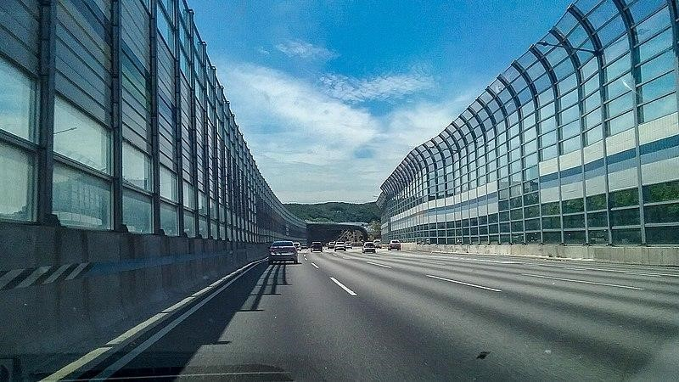

**2.NOISE REDUCING ROAD SURFACES:**

The city of Delft managed to **reduce road traffic noise by 6 dB** thanks to *quiet asphalt.* Studies that the limit for this technology is between 4 and 6 dB although limited, for urban environments it is very useful and considerably more affordable than noise barriers.

**3.LOWER SPEEDS:**

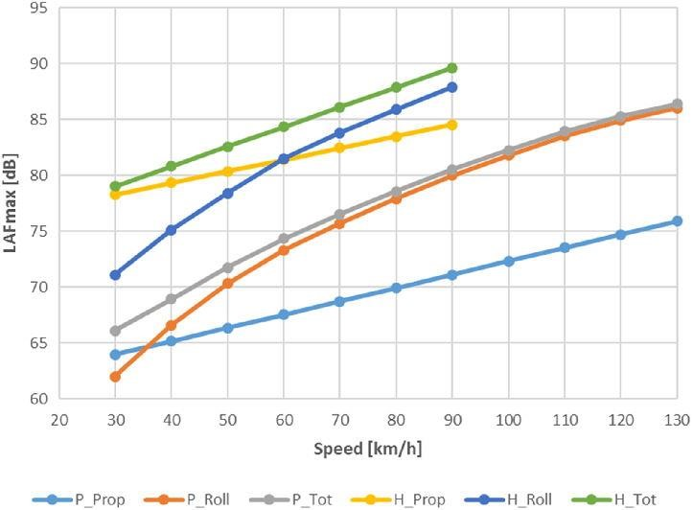

"If you can't remove motorized vehicles, the next best thing is to **reduce their speed**", according to the mobility expert Jason Slaughter in 'Cities Aren't Loud: Cars Are Loud'.

For any type of engine, greater speed means more noise, as shown in the graph. That is why often policies to reduce noise pollution (and [increase road safety)](https://tomorrow.city/a/what-is-the-evolution-use-car-city) consist in **changing infrastructures to reduce speed.** (Signs by themselves [only reduce a couple of km/h.](https://www.roadsafetyknowledgecentre.org.uk/downloads/20mph-reportv1.0-FINAL.pdf)

ELECTRIC VEHICLES:

[More space is also being given to electric vehicles](https://tomorrow.city/a/integrating-electric-vehicle-charging-points-into-the-urban-architecture) which, at low speeds are very quiet, however, given their volume, they can sometimes be noisier than an internal combustion vehicle at high speeds.

4.VEGETATION SURRONDING ROADS:

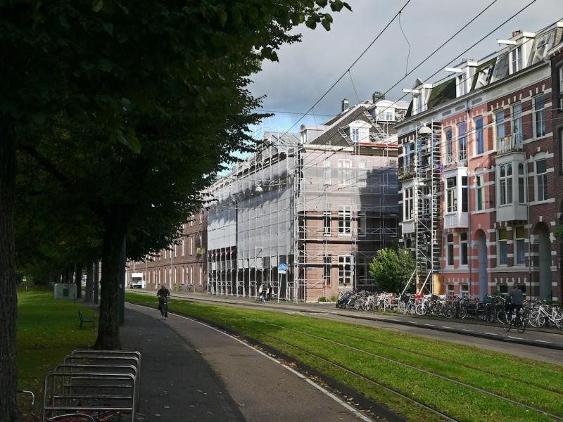

Green borders covered with plants running alongside a road are **clearly a non-tech element,** but incredibly functional. However, studies on the effectiveness of this solution, which is high, are at the forefront of technology. Very often, the best technology we can use is the oldest available to us.

5.HIGH –TECH BIKES:

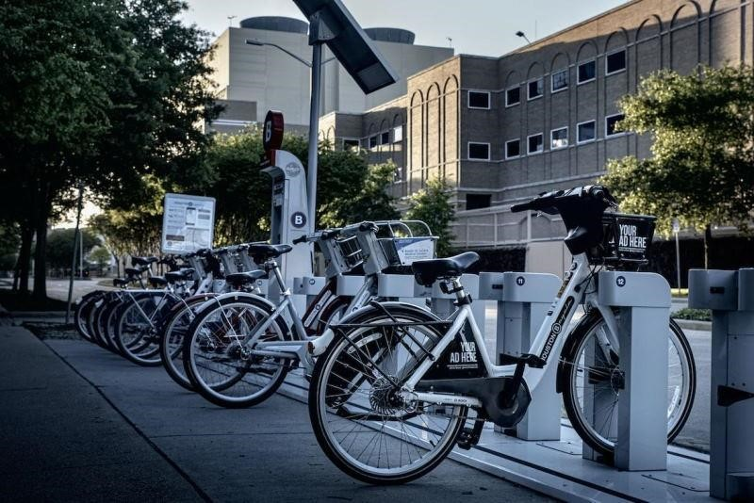

Bikes are not generally considered to be a technological element, but the way in which they are introduced in cities on a sharing basis with electric assistance, in automated docks and digitized with photovoltaic cells that charge with solar panels are high-tech indeed. And they are silent and silencing. It has been proven that bikes reduce average speeds and in turn traffic noise; and this reduces the number of vehicles.

In the urban battle against noise, all these technical, technological and scientific solutions are going to be required in order to reduce the noise thresholds to values that are not harmful to people. The mere presence of people can create noise levels that are high enough to bother residents, therefore part of the technical solutions entails **laws that focus on inappropriate or bothersome behaviors.**

**DEVELOPMENT OF NOISE MONITORING IN INDIA**

With increasing urbanization and industrialization, noise pollution particularly in ambient is also increasing. Government of India have taken number of steps to control noise pollution such as notifying noise rules-2009 and prescribing noise standards for vehicles, generators sets, fire crackers etc. Till now Maharashtra Pollution Control Board is carrying out noise monitoring in urban area during festival periods (Diwali and Ganapati) and ambient noise monitoring in 6 major cities of Maharashtra is being carried out once in a year at fixed locations and the reports of these monitoring are being displayed in the public domain through MPCB web site.

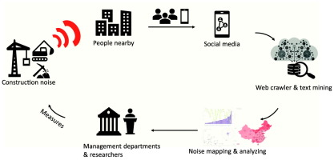

The Honourable Minister of Environment and forest has announced the road amp of systematic monitoring of ambient noise under the National Ambient Noise Monitoring Network Programme (NANMP) in the month of January, 2010. As per the proposed road map 10 continuous monitoring stations are to be established in each of seven identified cities .

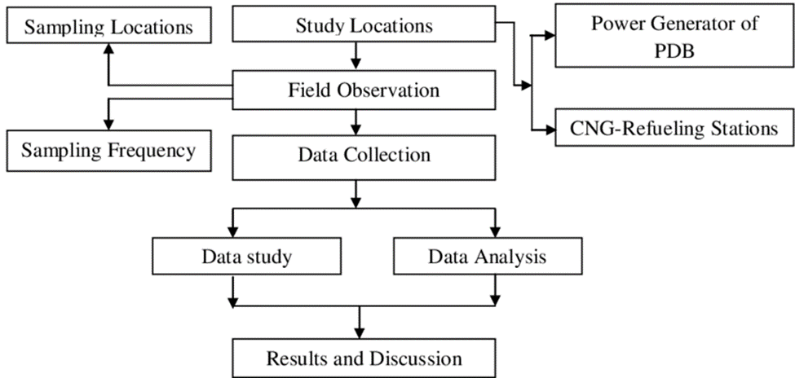



Mumbai, Delhi, Kolkata, Bangalore, Chennai, Lucknow and Hydra bad. Out of 10 stations proposed in Mumbai, 5 continuous monitoring stations have been installed at Mumbai/Navi Mumbai/Thane area at following locations: 1. Bandra, 2. Wadala, 3.Mahape (Navi Mumbai), 4. Vashi (Navi Mumbai) and 5. Thane Municipal Corporation Building (Thane). These above stations are in networking and real time noise data is being transmitted to the central server at CPCB. Glimpse of Noise Monitoring Stations

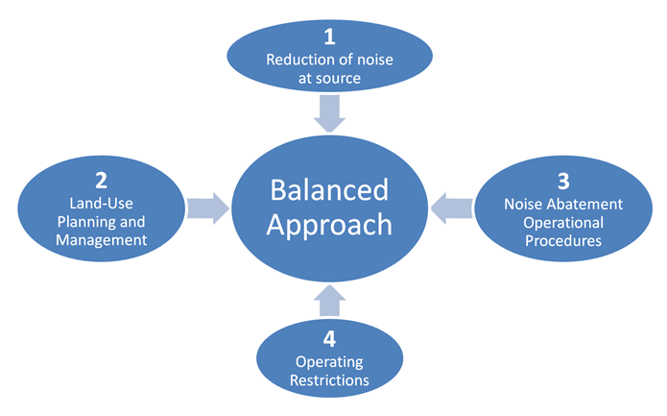

**DEVELOPMENT :**

1.Hardware development

2.App development

**1.HARDWARE DEVELOPMENT:**

For the hardware parts, LM 393 sound sensor is used to read the readings of the sound level from the environment. The reading of sound sensor is calibrated using the real sound level meter to ge t the accurate readings of the sound level. The 16x2 LCD will show the values of sound level at that researched area and give the warning that says the level of sound is high when the measurement exceeds the set value. If the users could not read the readings due to poor eyesight, they can know the level of sound by using the light emitting diodes (LED) which in red, blue and green colour placed below the LCD. LED acts as an indicator to indicate when the noise is very high. It will turn to red, blue for low noise while green for intermediate level. All these components such as sound sensor, LCD, and LEDs will be connected to

the ESP8266 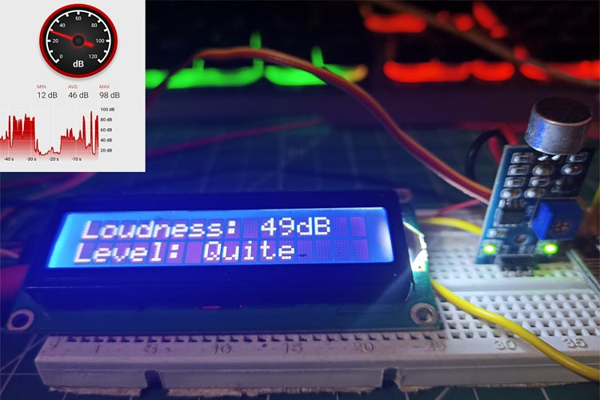

2.APP DEVELOPMENT:

As the app was created by using Android Studio, the app will display the data taken from the sound sensor. Android Studio is a software to create app use JAVA language to design an Android development. The app has four features which are the reading of sound level in dBA, the level of warning based on the reading of sound intensity, the possible sound that contributes to the sound level and the suitability for students to study. The app gives different level of warning such as “low”, “normal”, “high”.

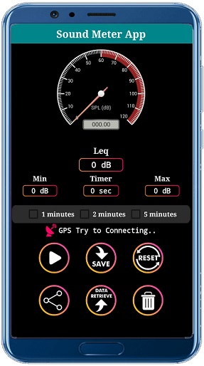

**PROGRAM FOR NOISE POLLUTION MONITORING:**

import sounddevice as sd

import numpy as np

import wavio

# Define recording parameters

duration = 10 # Duration of recording in seconds

sample_rate = 44100 # Sample rate

print("Recording...")

# Record audio data

audio_data = sd.rec(int(duration * sample_rate), samplerate=sample_rate, channels=1)

sd.wait()

print("Recording complete.")

# Save the recorded audio to a WAV file

wavio.write("recorded_audio.wav", audio_data, sample_rate, sampwidth=2)

print("Audio saved as 'recorded_audio.wav'")

**OUTPUT:**

Recording...

Recording complete.

Audio saved as 'recorded_audio.wav'

The code first prints "Recording..." to indicate that the recording process has started. After recording is complete, it prints "Recording complete." Finally, it prints "Audio saved as 'recorded_audio.wav'" to inform you that the recorded audio has been saved to a WAV file named "recorded_audio.wav."